Ideation Phase
Define the Problem Statements
Date | 03 October 2026
Team ID | SWTID-2026-6471
Project Name | EduGenie: Google Gemini Powered Learning Assistant
Maximum Marks | 2 Marks

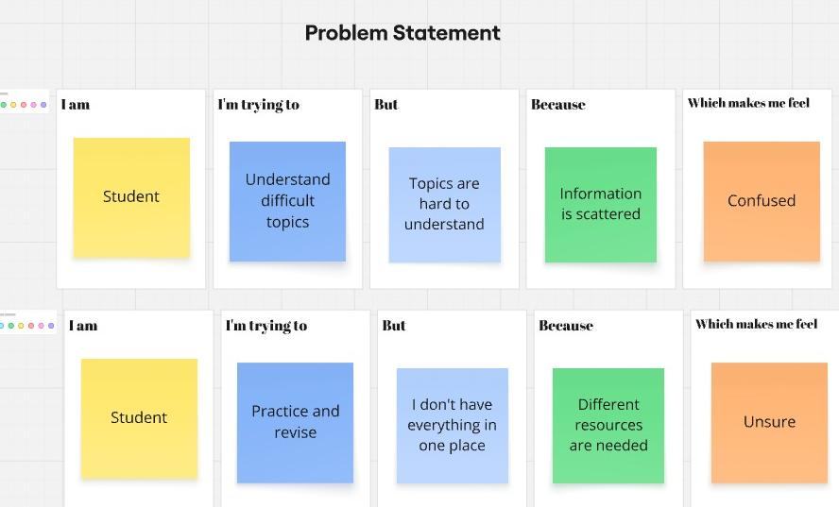

Problem  Statement (PS) | I am  (Customer) | I’m trying to | But | Because | Which makes me feel
PS-1 | Student | Understand difficult topics | Topics are hard to understanding | Information is Scattered | Confused
PS-2 | Student | Practice and revise | I don’t have everything in one place | Different source is needed | Unsure

